**Create Linux VM Using Azure CLI**

You can easily **create a linux virtual machine using Azure CLI** by using the below steps.

**Step-1:**Run the below command to create a **Resource Group** using **Azure CLI**.

az group create --name demoRsgGroup --location eastus

Once, you will execute the above command, you will get the output like below

{

"id": "/subscriptions/1cdf4300-dee5-4518-9c9c-feaa72a5cbd1/resourceGroups/demoRsgGroup",

"location": "eastus",

"managedBy": null,

"name": "demoRsgGroup",

"properties": {

"provisioningState": "Succeeded"

},

"tags": null,

"type": "Microsoft.Resources/resourceGroups"

}

**Step-2:** Now, execute the below command to create the VM using Azure CLI.

az vm create --resource-group demoRsgGroup --name TSINFOVM --image UbuntuLTS --admin-username azureuser --generate-ssh-keys

You can able to see it as below

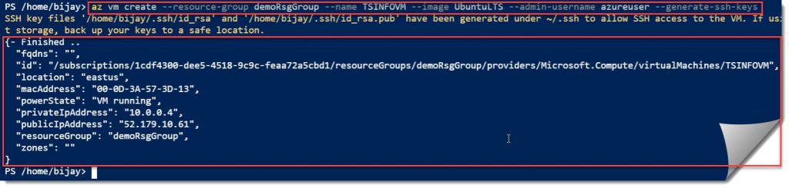**az vm create**

Once You will execute the above command, you will get the output like below

{- Finished ..

"fqdns": "",

"id": "/subscriptions/1cdf4300-dee5-4518-9c9c-feaa72a5cbd1/resourceGroups/demoRsgGroup/providers/Microsoft.Compute/virtualMachines/TSINFOVM",

"location": "eastus",

"macAddress": "00-0D-3A-57-3D-13",

"powerState": "VM running",

"privateIpAddress": "10.0.0.4",

"publicIpAddress": "52.179.10.61",

"resourceGroup": "demoRsgGroup",

"zones": ""

}

Now, to verify, you can navigate to the **Azure Portal** and can able to see the below**Azure Linux VM** created successfully.

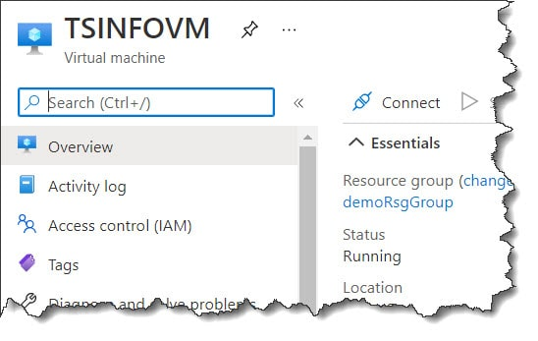

**Command To Create Virtual Machine In Azure**

You can use below command in **Azure CLI** to create the **Azure Virtual Machine**.

az vm create --resource-group Resource Group Name --name VM Name --image Win2016Datacenter --admin-username User Name --admin-password "Your Password" --location Location Name

Or,

New-AzVM

**PowerShell command to create VM in Azure** is as below. Refer to the above section for the complete details.

New-AzureRmVM -ResourceGroupName $vmresourceGroup -Location $location -VM $vmConfiguration

**az vm create**

You can use the **az vm create** command to quickly **create an Azure Virtual machine using Azure CLI**.

**Syntax:**

The syntax is as below

az vm create --resource-group Resource Group Name --name VM Name --image Win2016Datacenter --admin-username User Name --admin-password "Your Password" --location Location Name

**Example:**

Consider the below example

az vm create --resource-group myRsgGroup --name TSINFOVM2 --image Win2016Datacenter --admin-username rajkishore --admin-password "Password@123" --location eastus

In the above example.

* **myRsgGroup**— The name of the **Resource Group**.
* **TSINFOVM2**— Virtual machine name.
* **Win2016Datacenter**— Image name.
* **rajkishore**–The local admin username for the **VM**.
* **Password@123** –The local admin password for the **Virtual Machine**.
* **eastus** — The location name.